A/B Test Analysis Report
Boost Power Evaluation

Game Data Analysis
Delivery 2 - A/B Testing
Yiwei Ye
December 2025

1. Executive Summary
This report analyzes a 4-month A/B test conducted on a puzzle game to determine whether an increased boost power feature should be rolled out to all players.

Key Findings
- Players with stronger boost (Group A) achieved a 2.6 percentage point higher success rate (25.1% vs 22.5%)
- The difference is statistically significant (p < 0.001)
- Group A players used boosts 51% more frequently than Group B (15.6% vs 10.3%)
- The positive effect persisted even after the boost was reset to original power

Recommendation
Roll out the stronger boost to all players, with ongoing monitoring of long-term retention and monetization metrics.

2. Introduction & Background

2.1 Game Context
The game is a Candy Crush-style puzzle game where players attempt to complete levels. Players can use 'boosts' - power-ups that help them succeed at difficult levels. The game launched on January 1, 2020.

2.2 Business Problem
Players reported that some levels were too difficult, leading to frustration. The product team hypothesized that increasing the boost power would improve player experience and engagement without negatively impacting game balance.

2.3 Test Design
Group A (Test) | Received increased boost power
Group B (Control) | Retained original boost power
Test Period | June 1 - September 30, 2020
Sample Size | ~14,000 players (6,923 A, 7,017 B)

2.4 Research Question
Should the increased boost power be rolled out to all players?

3. Methodology

3.1 Data Sources
Dataset | Records | Key Fields
Users | 13,940 | TestGroup, demographics
Sessions | 432,000+ | Session timing
Levels | 1.5M+ | Attempts, boost, outcomes
Transactions | 26,000+ | Purchase data

3.2 Time Period Segmentation
Period | Dates | Purpose
Pre-Test | Jan 1 - May 31, 2020 | Baseline validation
During Test | June 1 - Sept 30, 2020 | A/B comparison
Post-Test | Oct 1 - Dec 31, 2020 | Persistence analysis

3.3 Statistical Methods
- Chi-squared test for comparing proportions between groups
- 95% Confidence Intervals for effect size estimation
- Odds Ratio for practical significance interpretation
- Significance threshold: α = 0.05

4. Results & Analysis

4.1 Baseline Validation
Before analyzing test results, we verified that Groups A and B were comparable before the test began.
Metric | Group A | Group B | p-value
Sample Size | 6,923 | 7,017 | -
Pre-Test Success Rate | 29.1% | 30.1% | 0.0016

Finding: There was a small but statistically significant difference in baseline success rates (1 percentage point). This is noted as a limitation, but the difference is small enough that it does not invalidate the test results.

4.2 Primary Finding: Level Success Rate
During the test period (June - September 2020):
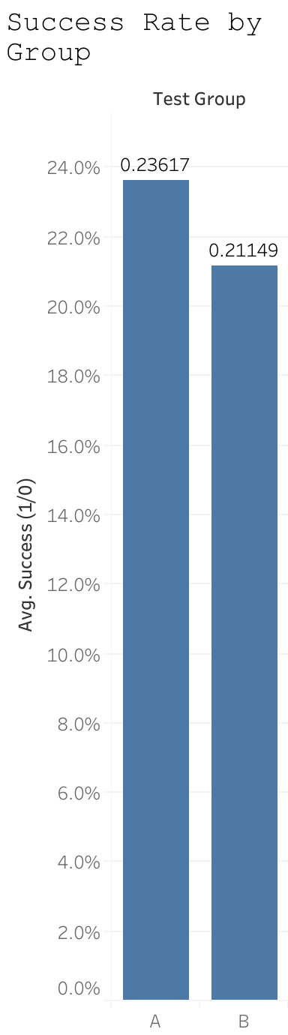
Figure 1: Success Rate by Test Group

Metric | Group A | Group B | Difference
Success Rate | 25.1% | 22.5% | +2.6 pp
Level Attempts | 399,219 | 394,339 | -

Statistical Test Results
- Chi-squared statistic: 797.84
- Degrees of freedom: 1
- p-value: < 2.2e-16 (highly significant)
- Odds Ratio: 1.15
- 95% CI for difference: [2.35%, 2.86%]

4.3 Time-Series Analysis
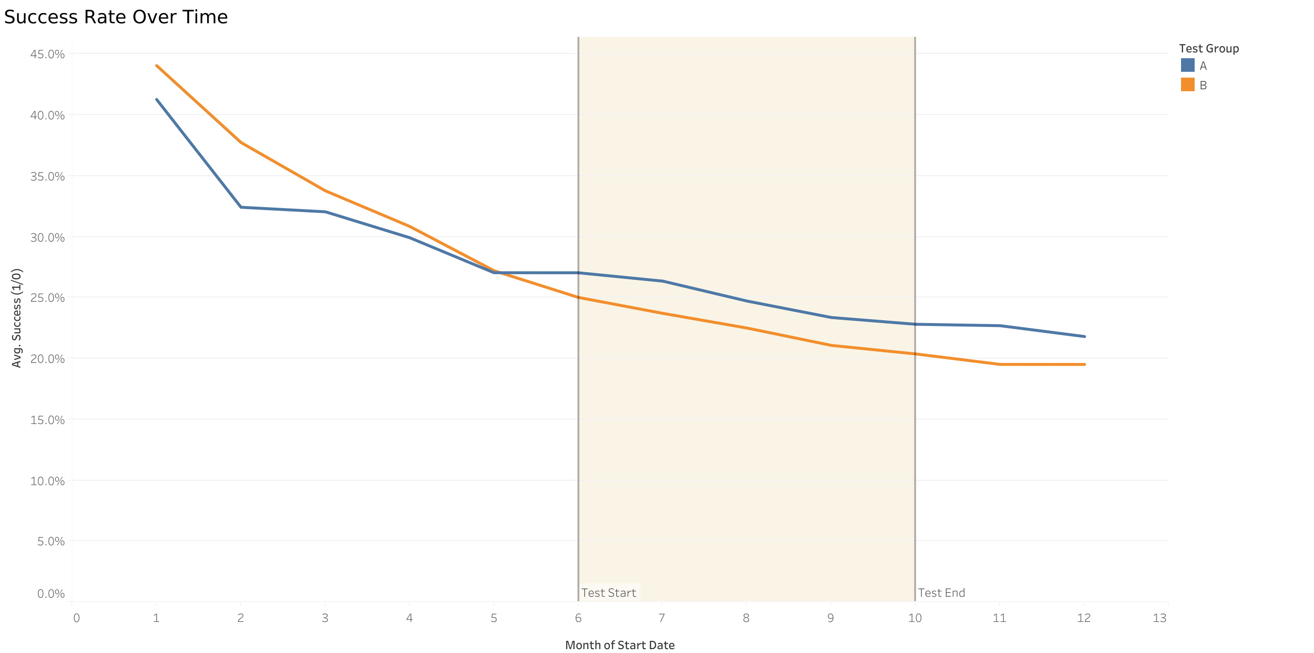
Figure 2: Success Rate Over Time by Test Group

The time-series visualization shows clear separation during the test period, with Group A consistently outperforming Group B. Notably, the effect persists even after the boost was reset in October.

4.4 Secondary Finding: Boost Engagement
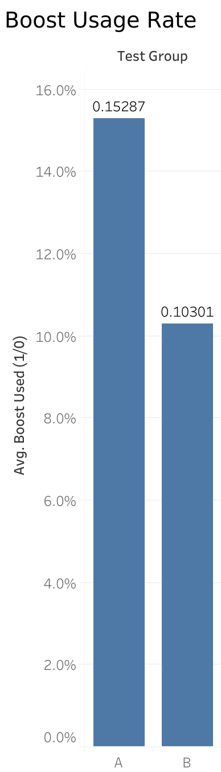
Figure 3: Boost Usage Rate by Test Group

Metric | Group A | Group B | Difference
Boost Usage Rate | 15.6% | 10.3% | +51%

Players used the boost significantly more when it was stronger (p < 0.001), indicating they recognized and appreciated the improved feature value.

4.5 Persistence Effect
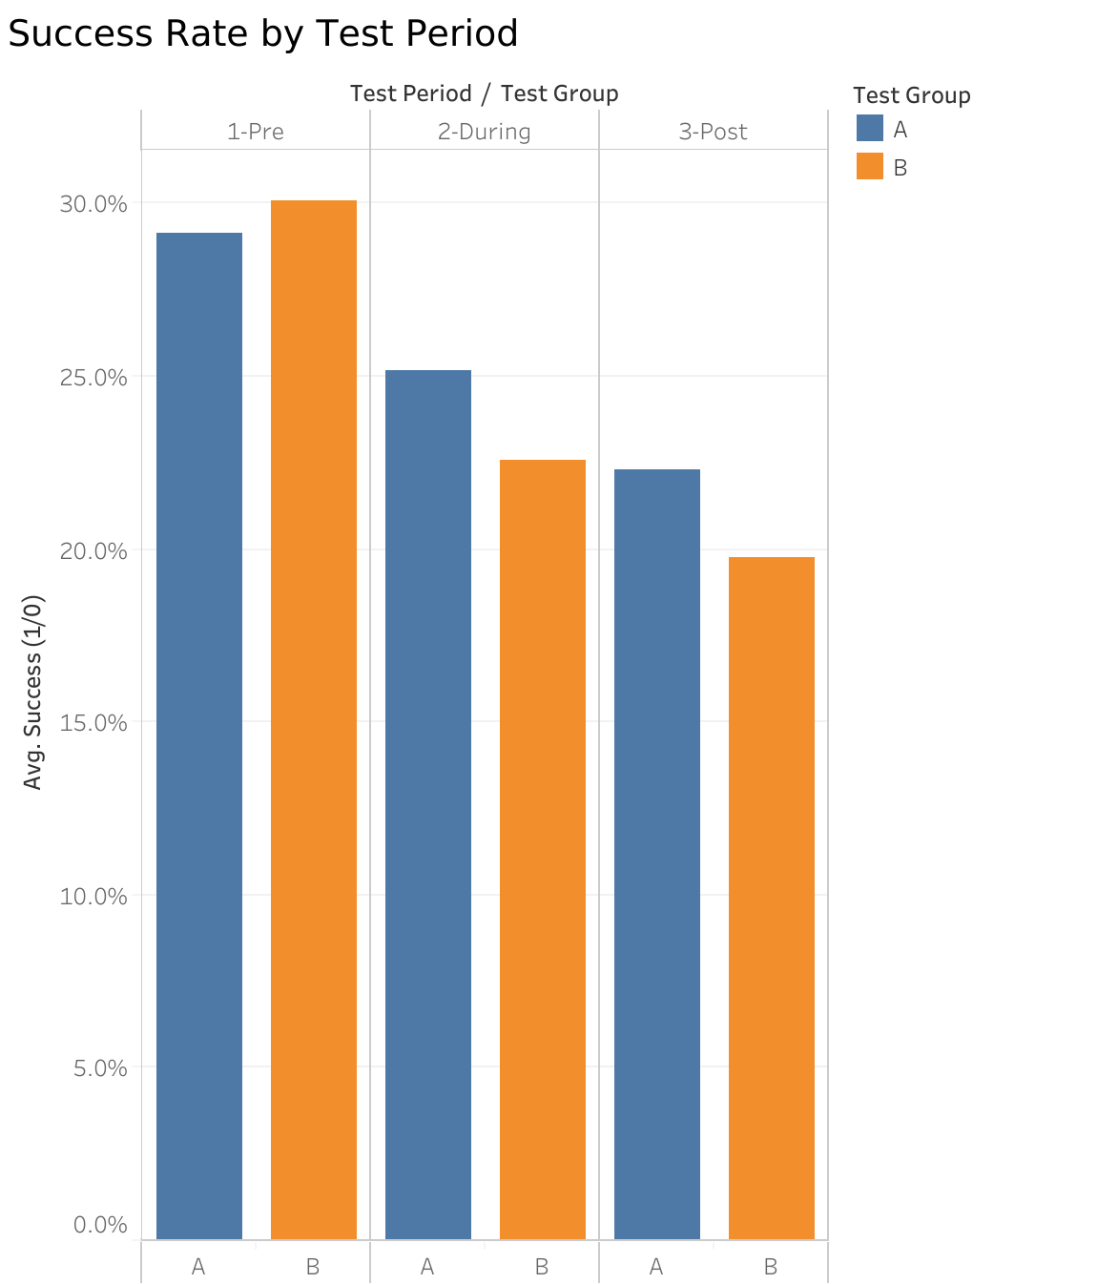
Figure 4: Success Rate by Test Period

Period | Group A | Group B | Difference
Pre-Test | 29.1% | 30.1% | -1.0 pp
During Test | 25.1% | 22.5% | +2.6 pp
Post-Test | 22.3% | 19.7% | +2.6 pp

Key Insight: Even after the boost was reset to original power, Group A continued to outperform Group B by the same margin. This suggests learned behavior or habit formation - players who experienced the stronger boost developed better strategies or confidence that persisted.

5. Discussion

5.1 Arguments FOR Rolling Out Stronger Boost
- Significant Performance Improvement: 2.6 percentage point increase with p < 0.001
- Higher Player Engagement: 51% increase in boost usage indicates feature value
- Lasting Positive Effects: Effect persists after reset, suggesting skill development
- No Observed Negative Effects: No decline in session frequency or engagement

5.2 Arguments AGAINST Rolling Out Stronger Boost
- May Reduce Game Challenge: Easier success could reduce long-term engagement
- Potential Boost Dependency: Players may become reliant on boosts
- Unknown Monetization Impact: Stronger free boost might reduce purchases
- Baseline Difference: Small pre-test difference suggests imperfect randomization

6. Conclusion & Recommendation

6.1 Summary of Findings
Test | Result | Significant?
Success Rate (During) | A > B by 2.6 pp | Yes (p < 0.001)
Boost Usage (During) | A > B by 51% | Yes (p < 0.001)
Baseline (Pre-Test) | Similar (1 pp diff) | Minor concern
Persistence (Post-Test) | Effect persists | Yes (p < 0.001)

6.2 Final Recommendation
RECOMMEND: Roll out the stronger boost to all players

The evidence strongly supports this decision:
- Clear, statistically significant improvement in player success
- Increased engagement with the boost feature
- Positive lasting effects on player behavior
- No observed negative consequences during the test period

6.3 Suggested Next Steps
- Monitor Long-Term Metrics: Track D7, D30, D90 retention after rollout
- Analyze Monetization Impact: Compare ARPU and boost purchase behavior
- Consider Level Rebalancing: Review difficulty curves if needed
- A/B Test Monetization: Test pricing changes if boost purchases decline

